- Go to Start/Program Files/Microsoft Dynamics CRM 4.0 Folder - click Configuration Wizard

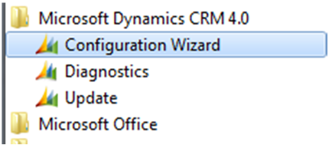

- The Wizard will open with its welcome message - Click Next

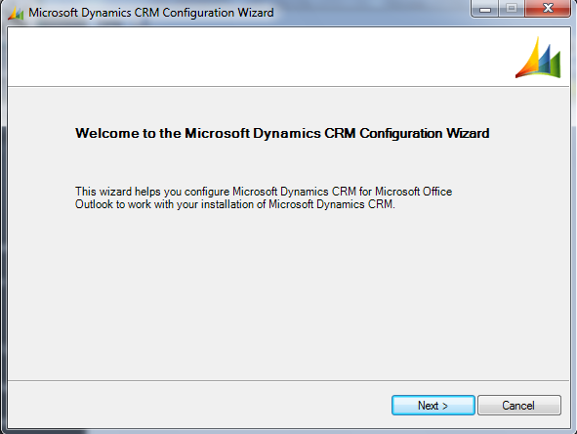

- You now need to decide which CRM service you need to connect to - Click 'An online service provider' then Next.

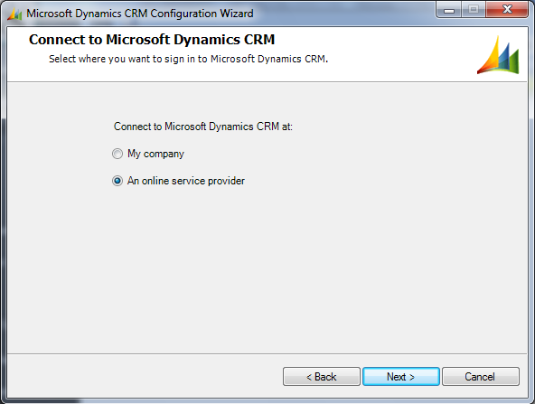

- Now you need to specify the web address of the CRM server - type https://scapadev2.hostedcrm4.net or https://scapacom.hostedcrm4.net and click Next. * Scapadev2 is the Development platform and scapacom is the Production platform.

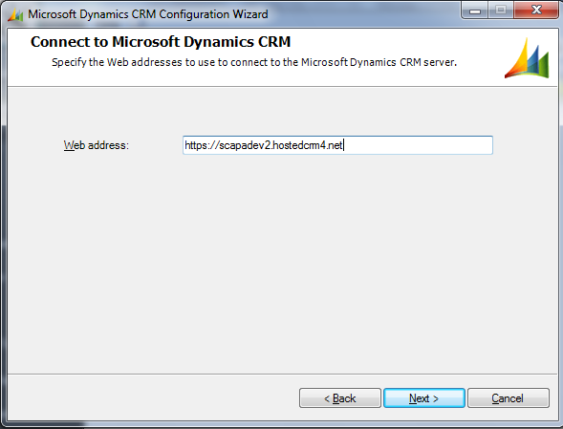

- Now enter your account details and click OK. Your details will be - firstname.lastname@scapadev2.com or firstname.lastname@scapa.com and the password is Password1 * The Scapadev2 account is the Development platform and scapa.com is the Production platform.

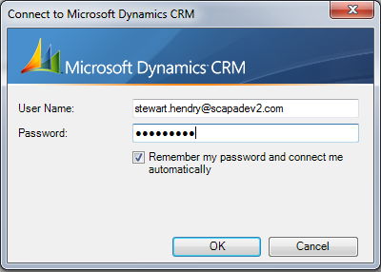

- Applying configuration - Select 'Delete existing database and create a new database' and click Next.

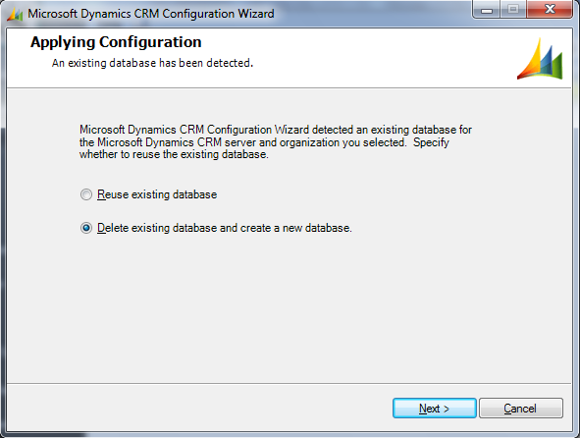

- Ignore this next screen - Click Next.

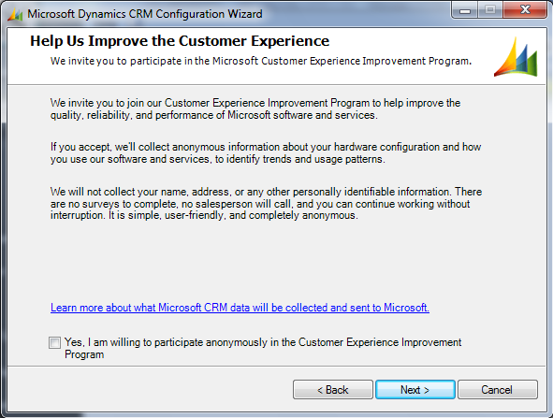

Screen clipping taken: 23/10/2009, 13:14

- Your details are now processed, please wait while it does this....

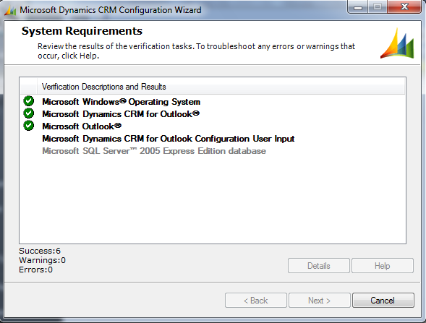

- After it has completed, you can click Next.

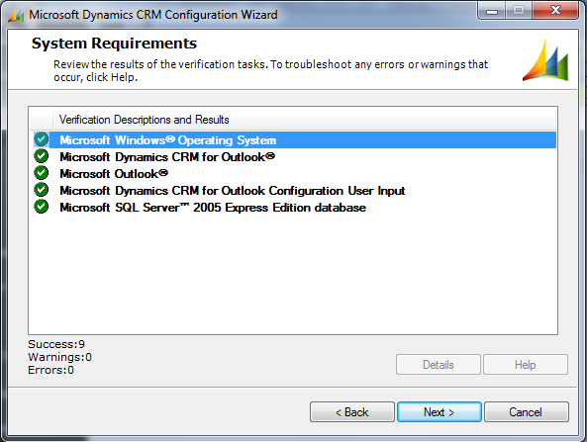

Screen clipping taken: 23/10/2009, 13:16
- The database will now be created for you

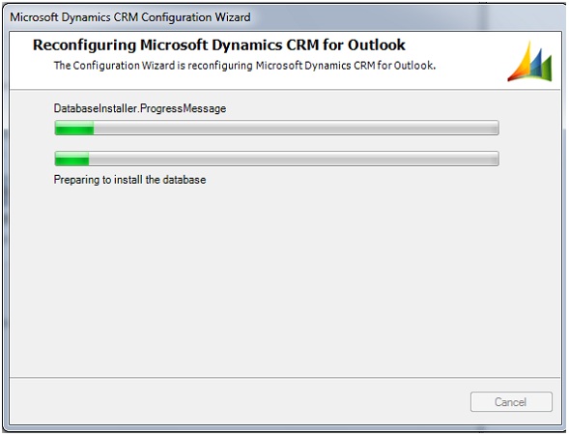

- When Configuration has been completed, you will see this screen and can click 'Finish'

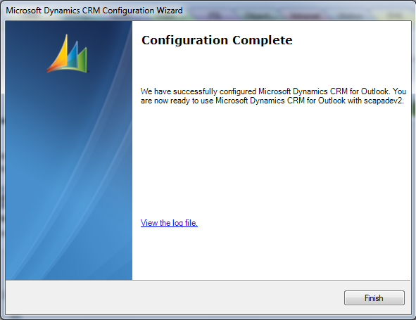

Screen clipping taken: 23/10/2009, 13:21
- You can now open Outlook. When prompted enter your account details

- Your Outlook will now have another Add-in/Toolbar, which will synchronise as you start.

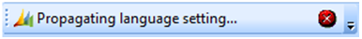

- When fully loaded, your Outlook will show the toolbar

